COMP3066 – Week 01 and 02 Assignment

- This is an individual assignment.
- The completed work has to be uploaded to the drop box on D2L. Email submissions will not be accepted.
- The screenshot taking guidelines must be followed (these can be found in our course on D2L under the “Course Content”.

Objective: To install Open SUSE Leap 15 64 bit Linux.

Task 01

- VMWare Workstation is already installed in the lab (RM C412). Use the following information if you do not have VMWare Workstation installed on your own PC and would like to do the course work on your PC.
- Download and install one of the following virtualization applications: VMWare Player/Workstation or VirtualBox

- VMWare Workstation/Player
  - VMware Workstation: https://softwareupdate.vmware.com/cds/vmw-desktop/ws/
  - VMware Player: https://softwareupdate.vmware.com/cds/vmw-desktop/player/
  - VMware Fusion: https://softwareupdate.vmware.com/cds/vmw-desktop/fusion/

- VMWare Tools can be found inside the VMware Workstation directories. For example:
  - https://softwareupdate.vmware.com/cds/vmw-desktop/ws/17.5.2/23775571/linux/packages/
  - https://softwareupdate.vmware.com/cds/vmw-desktop/ws/17.5.2/23775571/windows/packages/

- VirtualBox
  - Can be downloaded from the following url:
    - https://www.virtualbox.org/wiki/Downloads
  - Use the VirtualBox user manual for installation instructions and instructions on how to create and configure virtual machines. The VirtualBox user manual can be found at the following url/s:
    - V6.0 https://docs.oracle.com/cd/E97728_01/E97727/E97727.pdf
    - V6.1 https://docs.oracle.com/en/virtualization/virtualbox/6.1/user/
    - V7 https://download.virtualbox.org/virtualbox/UserManual.pdf

- Create a virtual machine for the installation of Open SUSE Leap 15 64 bit Linux (watch the video to learn how to create the Linux VM). The requirements for the Virtual Machine:
  - Type: Linux (other Linux, latest 64bit kernel)
  - Name: OpenSUSE 15.6 64bit
  - Hard Drive – 20GB
  - RAM – at least 2GB
  - Number of Processor Cores (processors) – 2
  - Network Adapter - NAT

Task 02

Download OpenSUSE from the following URL: https://download.opensuse.org/distribution/leap/15.6/iso/openSUSE-Leap-15.6-DVD-x86_64-Media.iso

Install the downloaded Open SUSE Leap 15 64 bit Linux.

Requirements for installing OpenSUSE Linux:

- download the full 4.7GB DVD ISO image, not the Live version
- set language and keyboard to English US
- set timezone to Canada/Eastern Toronto
- select the KDE user interface
- activate the suggested online repositories
- create a Linux user account;
  - Full Name – your full last and first names
  - User Name – your lastname and the first letter of the first name. For example: my name is Nikolai Ivanov and my user name will be ivanovn
  - do not choose to log in automatically
- set the hostname of your Linux VM to be your full last name, the dash character, and the two letters of the first name. For example: my name is Nikolai Ivanov and my host name will be ivanov-ni
  - https://www.redhat.com/sysadmin/configure-hostname-linux
- create four partitions as shown below:
  - sda1 - BIOS Boot Partition, size: 10MB, Mount Point: none, File System: raw, unformatted
  - sda2 - Swap Partition, size: 2GB, Mount Point: swap, File System: swap
  - sda3 - System Partition, size: 3GB, Mount Point: /home, File System: ext4
  - sda4 - System Partition, size: 14.99GB, Mont Point: /, File System: ext4

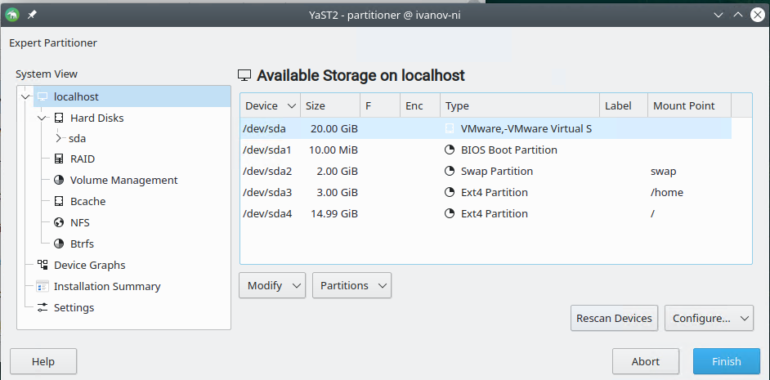
- Follow the installation instructions found in the Section 01 of the course textbook (you can download the course textbook from the D2L).

- Alternatively, you can use the Installation Quick Start Guide found at the following URLs:
  - https://doc.opensuse.org/documentation/leap/startup/html/book-startup/art-opensuse-installquick.html
  - https://opensuse-guide.org/

- Use the KDE Quick Start Guide to become familiar with the KDE Linux user interface. The Quick Start Guide can be found at the following url:
  - https://opensuse-guide.org/kde.php

Submission:

Take the screenshots of your work as requested below and submit this completed document to the dropbox on D2L:

1. running OpenSUSE Linux with the start menu open

replace the sample screenshot with your own screenshot:

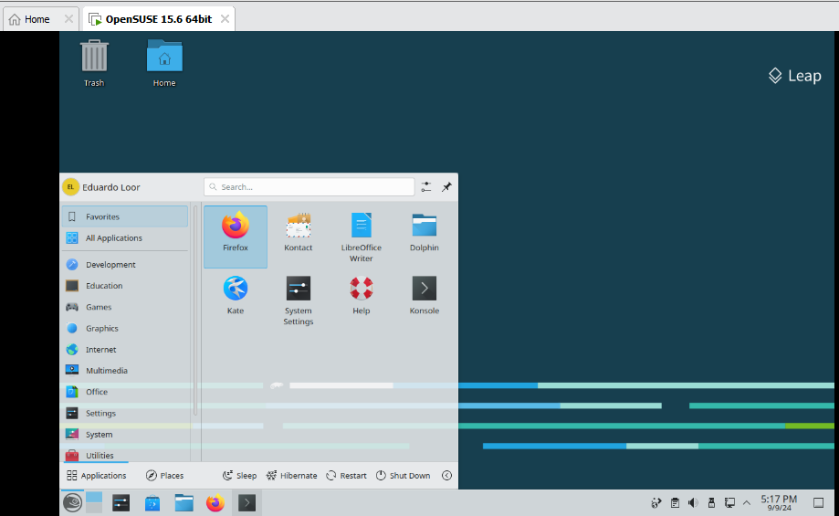

2. Terminal window showing the hostname and the output of the “sudo fdisk -l” command:

replace the sample screenshot with your own screenshot:

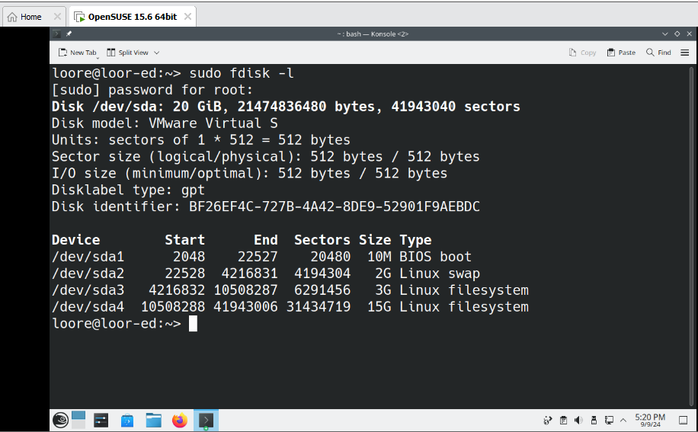

3. Terminal window showing the hostname and the output of the “ip add show” command:

replace the sample screenshot with your own screenshot:

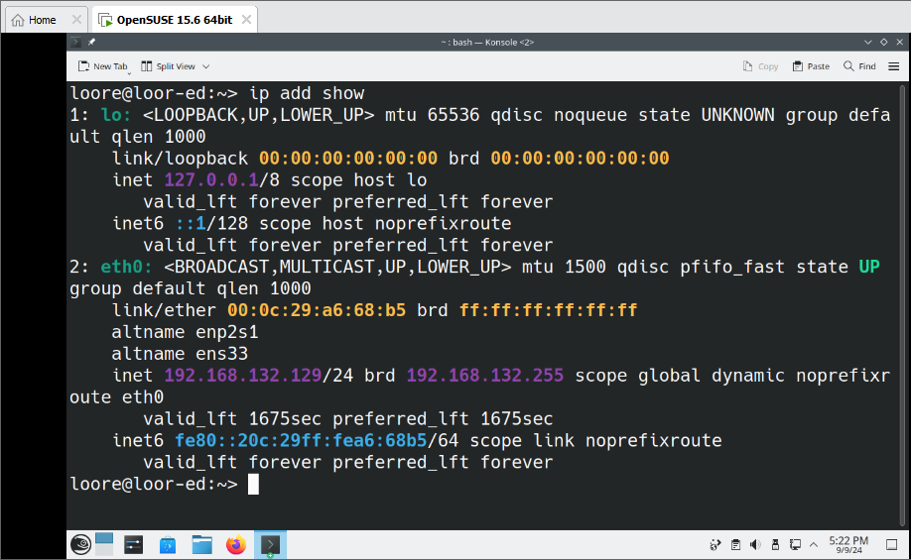
4. Terminal window showing the hostname and the output of the “id” command:

replace the sample screenshot with your own:

